**Cloud Computing**

* **Introduction of Cloud Computing: *"The cloud"*** refers to servers that are accessed over the Internet and the software and databases that run on those servers. Cloud servers are in data centers all over the world. By using cloud computing, users and companies do not have to manage physical servers themselves or run software applications on their own machines.

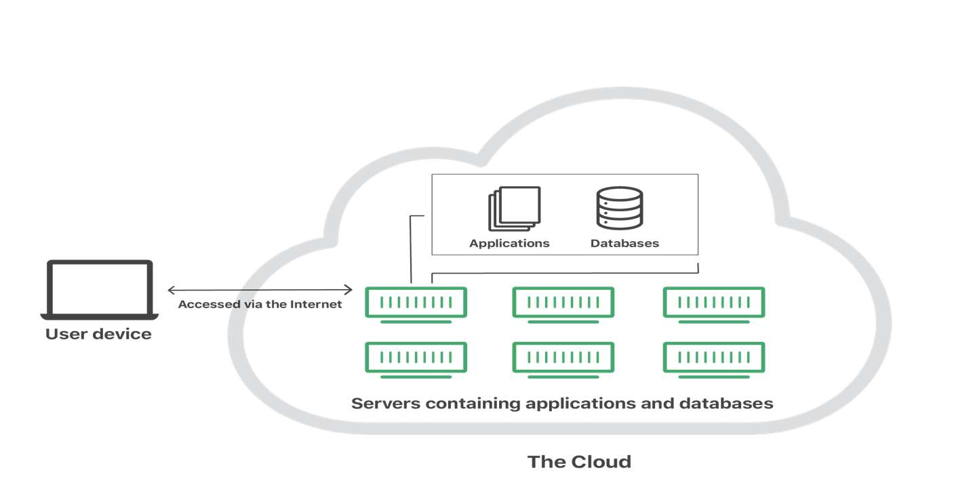

* ***The cloud enables users to access the same files and applications from almost any device, because the computing and storage takes place on servers in a data center, instead of locally on the user device.*** Therefore, a user can log into their Instagram account on a new phone after their old phone breaks and still find their old account in place, with all their photos, videos, and conversation history. It works the same way with cloud email providers like Gmail or Microsoft Office 365, and with cloud storage providers like Dropbox or Google Drive.
* **Definition of Cloud Computing:** The term **“Cloud Computing”** refers to services provided by the cloud that is responsible fordelivering of computing services such as servers, storage, databases, networking, software,analytics, intelligence, and more, over the Cloud (Internet).Cloud computing applies a virtualized platform with elastic resources on demand by provisioning hardware, software, and data sets dynamically.

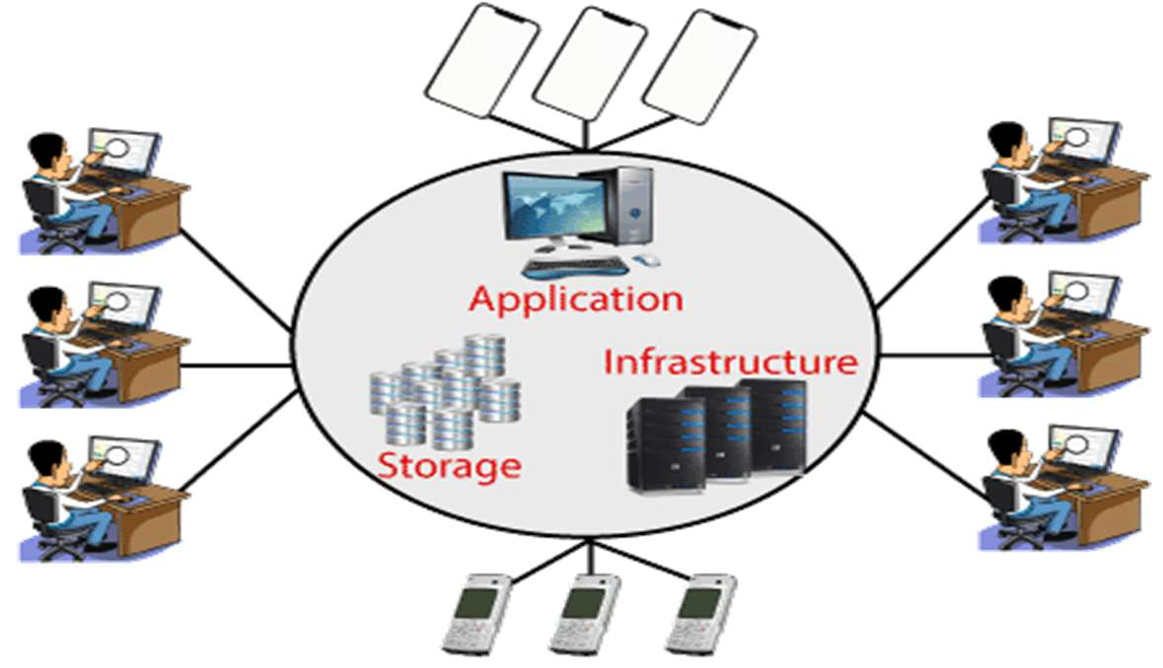

* ***Cloud Computing provides an alternative to the on-premises data center.*** With an on- premises data center, we must manage everything, such as purchasing and installing hardware, virtualization, installing the operating system, and any other required applications, setting up the network, configuring the firewall, and setting up storage for data. After doing all the set-up, we become responsible for maintaining it through its entire lifecycle.

However, if we choose Cloud Computing, ***a cloud vendor is responsible for the hardware purchase and maintenance. They also provide a wide variety of software and platform as a service.*** We can take any required services on rent. The cloud computing services are charged based on usage.

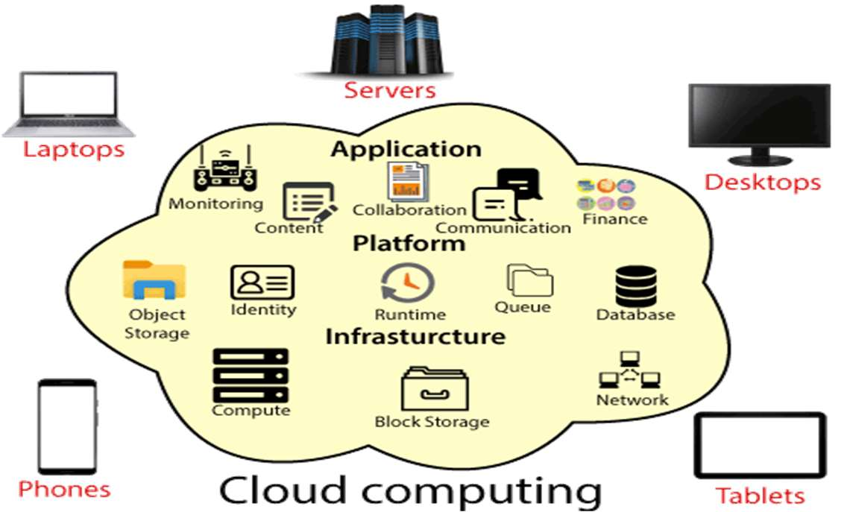

* **Advantages of Cloud Computing:**
* **Cost:** It reduces the huge capital costs of buying hardware and software.
* **Speed:** Resources can be accessed in minutes, typically within a few clicks.
* **Scalability:** We can increase or decrease the requirement of resources according to the business requirements.
* **Productivity:** While using cloud computing, we put less operational effort. We do not need to apply patching, as well as no need to maintain hardware and software. So, in this way, the IT team can be more productive and focus on achieving business goals.
* **Reliability:** Backup and recovery of data are less expensive and extremely fast for business continuity.
* **Security:** Many cloud vendors offer a broad set of policies, technologies, and controls that strengthen our data security.
* **Cloud computing shares characteristics with:**
* **Client–server model:** Client–server computing refers broadly to any distributed application that distinguishes between service providers (servers) and service requestors (clients).
* **Grid computing**: A form of distributed and parallel computing, where by a super and virtual computer is composed of a cluster of networked, loosely coupled computers acting in concert to perform very large tasks.
* **Fog computing:** Distributed computing paradigm that provides data, computer, storage and application services closer to the client or near-user edge devices, such as network routers. Furthermore, fog computing handles data at the network level, on smart devices and on the end-user client-side (e.g., mobile devices), instead of sending data to a remote location for processing.
* **Mainframe computer:** Powerful computers used mainly by large organizations for critical applications, typically bulk data processing such as census; industry and consumer statistics; police and secret intelligence services; enterprise resource planning; and financial transaction processing.
* **Utility computing:** The packaging of computing resources, such as computation and storage, as a metered service similar to a traditional public utility, such as electricity.
* **Peer-to-peer:** A distributed architecture without the need for central coordination. Participants are both suppliers and consumers of resources (in contrast to the traditional client-server model).
* **Green computing:** Study and practice of environmentally sustainable computing or IT.
* **Cloud sandbox:** A live, isolated computer environment in which a program, code or file can run without affecting the application in which it runs.
* **Characteristics of Cloud Computing:**
* Agility for organizations
* Cost reductions, Centralization of infrastructure in locations with lower costs.
* Device and location independence, which means no maintenance, required.
* Pay-per-use means utilization and efficiency improvements for systems that are often only 10–20% utilized.
* Performances are being monitored by IT experts i.e., from the service provider end.
* Productivity increases which results in multiple users who can work on the same data simultaneously.
* Time may be saved as information does not need to be re-entered when fields are matched.
* Availability improves with the use of multiple redundant sites
* Scalability and elasticity via dynamic ("on-demand") provisioning of resources on a fine-grained, self-service basis in near real-time without users having to engineer for peak loads.
* Self-service interface.
* Resources that is abstracted or virtualized.
* Security can improve due to centralization of data
* The **NIST (National Institute of Standards and Technology)** model in cloud computing is a widely accepted framework for understanding and evaluating cloud computing services. The ***National Institute of Standards and Technology***'s definition of cloud computing identifies **“five essential characteristics”**:

**Essential Characteristics -**

1. **On-demand self-service:** Cloud resources can be provisioned and de-provisioned automatically without human intervention.
2. **Broad network access:** Cloud resources are accessible over the internet or a private network.
3. **Resource pooling:** Cloud resources are pooled together to provide a multi-tenant environment.
4. **Rapid elasticity:** Cloud resources can be quickly scaled up or down to match changing business needs.
5. **Measured service:** Cloud resources are metered and billed according to usage.

**Service Models -**

1. **Infrastructure as a Service (IaaS):** Provides virtualized computing resources, such as servers, storage, and networking.
2. **Platform as a Service (PaaS):** Provides a complete platform for developing, running, and managing applications, including tools, libraries, and infrastructure.
3. **Software as a Service (SaaS):** Provides software applications over the internet, eliminating the need for local installation and maintenance.

**Deployment Models -**

1. **Public Cloud:** A cloud environment opens to the general public, owned and operated by a third-party provider.
2. **Private Cloud:** A cloud environment provisioned and managed within an organization's premises, for its own use.
3. **Hybrid Cloud:** A cloud environment that combines public and private cloud services, allowing for data and applications to be shared between them.
4. **Community Cloud:** A cloud environment provisioned and managed by a group of organizations with similar interests or goals.

**NOTE:** ***The NIST cloud computing model provides a comprehensive framework for understanding the characteristics, service models, and deployment models of cloud computing. This model helps organizations make informed decisions when adopting cloud computing services.***

* **Cloud service providers Properties:** Cloud service providers (CSPs) are companies that offer various cloud-based services to individuals and businesses. These services can include anything from computing power and storage to software applications and development platforms.

**Key Properties of Cloud Service Providers:**

1. **Scalability:** Cloud services can be easily scaled up or down based on demand, allowing users to adjust their resources as needed.
2. **Cost-effectiveness:** Cloud services often operate on a pay-as-you-go model, which can be more cost-effective than investing in and maintaining on-premises infrastructure.
3. **Accessibility:** Cloud services can be accessed from anywhere with an internet connection, making them ideal for remote work and collaboration.
4. **Reliability:** CSPs typically have robust infrastructure and redundancy measures in place to ensure high availability and minimize downtime.
5. **Security:** CSPs invest heavily in security measures to protect user data and ensure the integrity of their services.

**Top Cloud Service Providers:**

1. **Amazon Web Services (AWS):** A leading provider of a wide range of cloud services, including compute, storage, databases, analytics, and machine learning.
2. **Microsoft Azure:** Offers a comprehensive suite of cloud services, including compute, storage, databases, networking, and artificial intelligence.
3. **Google Cloud Platform (GCP):** Provides a variety of cloud services, with strengths in data analytics, machine learning, and containerization.
4. **Alibaba Cloud:** A major cloud provider in Asia, offering a range of services including compute, storage, databases, and artificial intelligence.
5. **IBM Cloud:** Offers a variety of cloud services, with a focus on hybrid cloud solutions and industry-specific offerings.

**Choosing a Cloud Service Provider:** When selecting a cloud service provider, it's essential to consider factors such as -

1. **Specific needs:** Determine the types of services required and the level of resources needed.
2. **Pricing:** Compare pricing models and ensure they align with your budget.
3. **Security:** Evaluate the provider's security measures and compliance certifications.
4. **Reliability:** Check the provider's uptime guarantees and service level agreements (SLAs).
5. **Support:** Assess the level of customer support provided by the CSP.